# INDUSTRIAL Process Control

# Process Control with ON/OFF Actuator

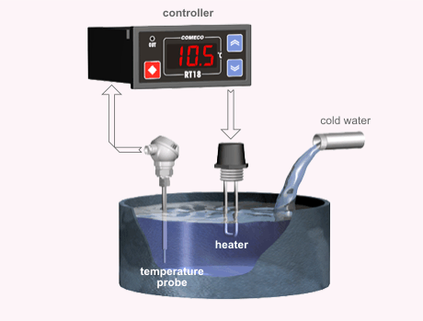

When a process variable such as temperature, pressure, relative humidity, etc. has to be kept constant, a control system is needed.  
In the system shown on the picture, the temperature controller measures water temperature and adjusts the heating power.

The heater is switched on and off in order to apply only the necessary part of full power.

When cold water flow changes, the temperature deviates from the desired value and the controller readjusts heating power to bring the temperature back. ON/OFF, P, PI, or PID controller may be used.

# Process Control with Double-action Actuator

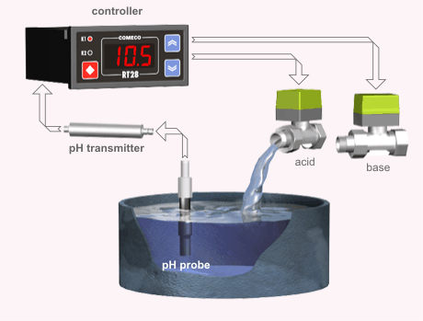

The controller measures solution acidity and opens acid or base source valve when necessary.

For this purpose the controller is fitted with two control relays.

The solenoid operated valve is open as long as the corresponding relay is on. ON/OFF, P, PI, or PID duplex controller may be used.

# Process Control with Motorized-valve Actuator

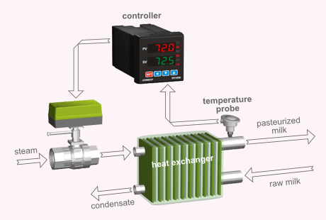

The controller measures milk temperature and adjusts the heating power by opening or closing the valve.

An increase or decrease of steam flow results in subsequent pasteurized milk temperature change.

When pasteurized milk temperature deviates from the desired value, the controller opens or closes the valve by steps to bring the temperature back.

ON/OFF duplex controller for motorized valve control may be applicable but PD controller will serve much better.

# High-precision Control with Cascaded Controllers

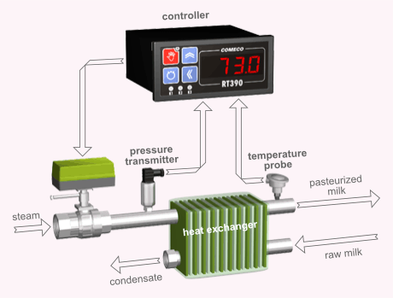

This type of control system requires two sensors.   
The main sensor measures the actual process variable.  
 The preliminary signal sensor measures a variable that reacts faster to control power changes.  
  
Such systems are applicable in two cases:

* systems where control action, after relatively long delay, causes  abrupt output change. Such systems are called "difficult".   
  An attempt   to achieve reasonably fast response with single input controller results   in process variable cycling.
* systems where interference alters control action. An example   is a valve for controlling saturated steam pressure (and consequently   temperature).   
  A specified degree of opening of the valve does not   guarantee certain output steam pressure as supply steam pressure   may vary.

In the system on the picture the pressure of the saturated steam to heat exchanger is controlled by a separate control loop.  
The desired value of the steam pressure in front of heat exchanger is set by the outer loop controlling milk temperature. In this way, any deviation of steam pressure due to mains pressure change will be early detected and eliminated before affecting milk temperature.  
Two cascaded controllers or one controller with two inputs and corresponding internal structure should be used. The outer loop  
controller should be PI or PID, while the internal loop controller may even be a simple ON/OFF type although PD or P controllers  
are usually used.

# Process Humidity Process Control in Drying Chambers

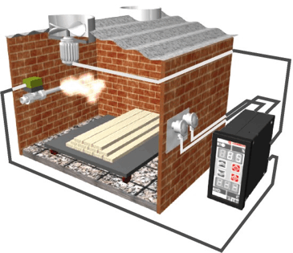

The most suitable method to measure relative humidity in high-temperature drying chambers is the psychrometric principal used with RHU sensors.

A special controller RT180 has 2 two inputs for connecting 'dry' and 'wet' resistance thermometers.

The controlleris also equipped with two relay outputs.   
One of the relays controls a fan in order to decrease the humidity, the other relay controls an ON/OFF actuator in order to increase the humidity.

An ON/OFF control algorithm with pulse mode should be used for both actuators. In this way, RT180 performs a 'portion' control of the incoming and outgoing humidity.

# Process Control with Pattern Set-point

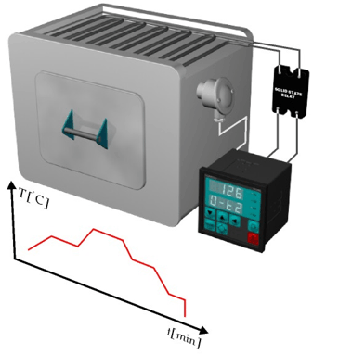

Many industrial processes (drying, sterilization, material thermal treatment, etc) require a time-variable process parameter,  
which is mainly temperature.   
A special 'pattern set-point' controller, such as RT1800, should be used when such demand exists.  
The operator can create and store in the controller memory, several different time programs.   
  
Each program consists of several points, described by a set-point value and its duration.

The controller claims (if it is physically possible) to control the process according to the previously created program and the selected control algorithm.

We recommend the usage of an external solid-state relay (SSR) as an actuator, when the oven is equipped with high-power heaters.